# Echonet Microphone prototype

## BOM-

* Arduino Uno R3
* Max9841 – Electec Microphone and Op-Amp
* DS1307 SD card shield
* LED
* Switch
* 100kohm resistor
* 8x Jumper leads
* Bread board

## Board setup

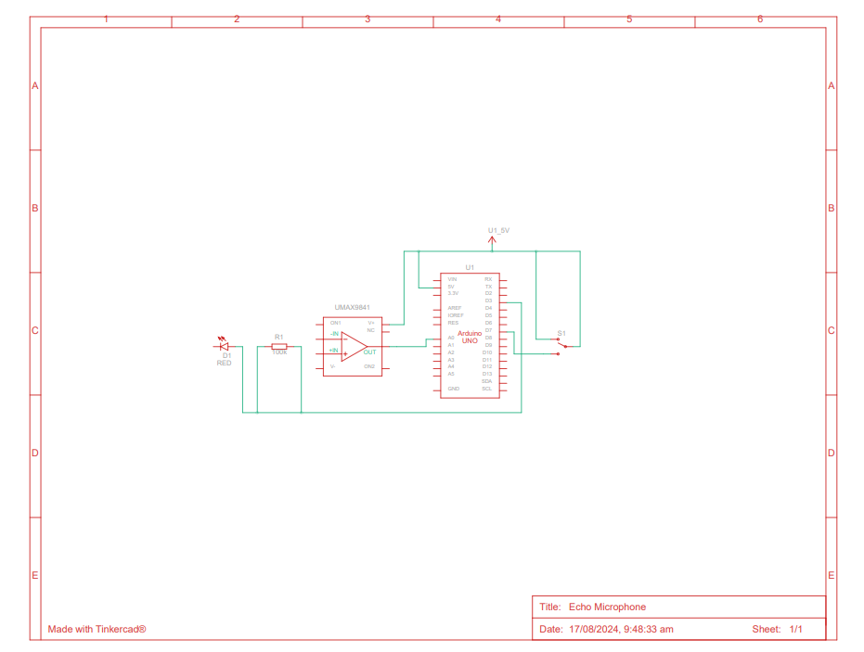

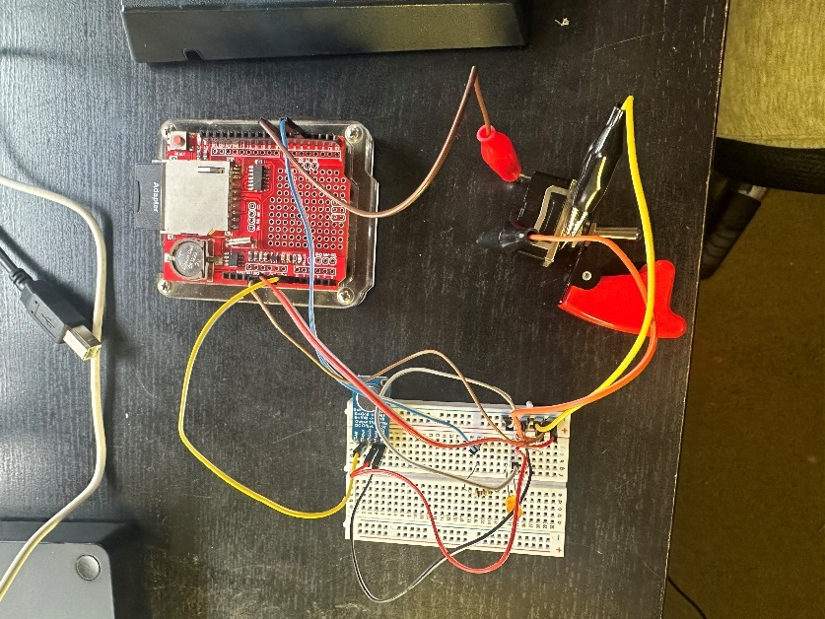

Set up notes I had a 100k resistor available and any suitable resistor before the LED should be fine.

The switch is what I had available at the time to implement a disable/ stop recording function in-line with the timer interrupt and works badly at best and needs replacement but gets the basic notion across.

The SD shield is not in the circuit diagram as not available in Tinker CAD and fits directly onto the UNO

The OP-amp Input connects directly to the microphone these are one breakout board also not available in Tinker CAD

### Firmware setup

The sound recording function of the TMRpcm library need to be activated this is done by finding the pcmConfig.h file I did this by using the search function and editing the variable

#define buffSize 128

And un commenting

#define ENABLE_RECORDING

#define BLOCK_COUNT 10000UL

Save the file and the recording should now work